# MySQL Introduction – Fall 2015 – LAB SQL 2

(Create a file that includes LabSQL2 and your initials in the filename. After answering the lab questions, submit your file on blackboard.)

// **LAB SQL 2**

Follow these steps and answer the questions:

# Populate the Participant table:

INSERT INTO participant (appointment_id, employee_id, role, estimatedDuration) VALUES (1, 1, 0, 60);

INSERT INTO participant (appointment_id, employee_id, role,

estimatedDuration) VALUES (1, 2, 1, 30);

INSERT INTO participant (appointment_id, employee_id, role, estimatedDuration) VALUES (1, 3, 1, 30);

INSERT INTO participant (appointment_id, employee_id, role, estimatedDuration) VALUES (2, 1, 0, 30);

INSERT INTO participant (appointment_id, employee_id, role, estimatedDuration) VALUES (2, 4, 1, 20);

# This query is meant to show the customer first name, last name, appointment date, employee first name, last name, and the estimated duration for each employee’s duration of work. Why doesn’t this query work? (HINT: try running it in MySQL):

The select statements do not identify which table they refer to.

* 1. SELECT firstName, lastName, appointmentDateTime, estimatedDuration, firstName, lastName FROM customer c JOIN appointment a ON c.customer_id=a.customer_id JOIN participant p ON a.appointment_id=p.appointment_id JOIN employee e ON p.employee_id=e.employee_id;
  2. Write out the corrected query.

SELECT c.firstName, c.lastName, a.appointmentDateTime, a.estimatedDuration, e.firstName, e.lastName

FROM customer c

JOIN appointment a

ON c.customer_id=a.customer_id

JOIN participant p

ON a.appointment_id=p.appointment_id

JOIN employee e

ON p.employee_id=e.employee_id;

* 1. Paste in a screenshot of the query result table.

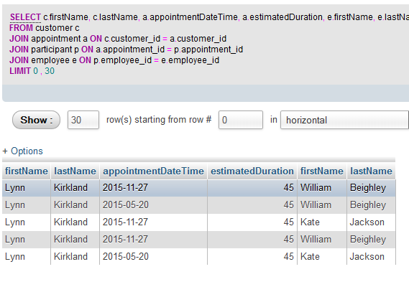

# Attempt to insert data into the participants table using this SQL statement:

INSERT INTO participants (employee_id, role, estimatedDuration)

VALUES (1, 0, 60);

* 1. Why won’t this work?
     1. Every required (NOT NULL) column must be provided a value.
     2. appointment_id cannot be NULL, therefore it should be

inserted for this statement to execute

* + 1. **Both i. and ii.**
    2. None of the above

# Which appointments did not have any participants, be sure to include the customer last name column and appointment date time column in the results?

1. Write out which columns and their associated tables are needed to answer this question.
2. What type of JOIN should be used?
   1. INNER
   2. CROSS
   3. **OUTER**
   4. SELF
3. Write out the query that gives the answer to this question.

SELECT c.lastName, a.appointmentDateTime, a.appointment_id

FROM customer c

JOIN appointment a

ON c.customer_id = a.customer_id

LEFT JOIN participant p

ON p.appointment_id = a.appointment_id

WHERE p.employee_id IS NULL;

1. Paste a screenshot of the result table.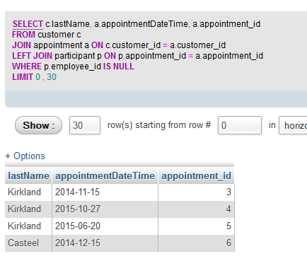

# Submit answers and diagrams to the instructor as described in class or on blackboard.

1. Submit a document with your screenshots and answers to the above steps in Lab SQL 2. Be sure to include your initials in the filename.